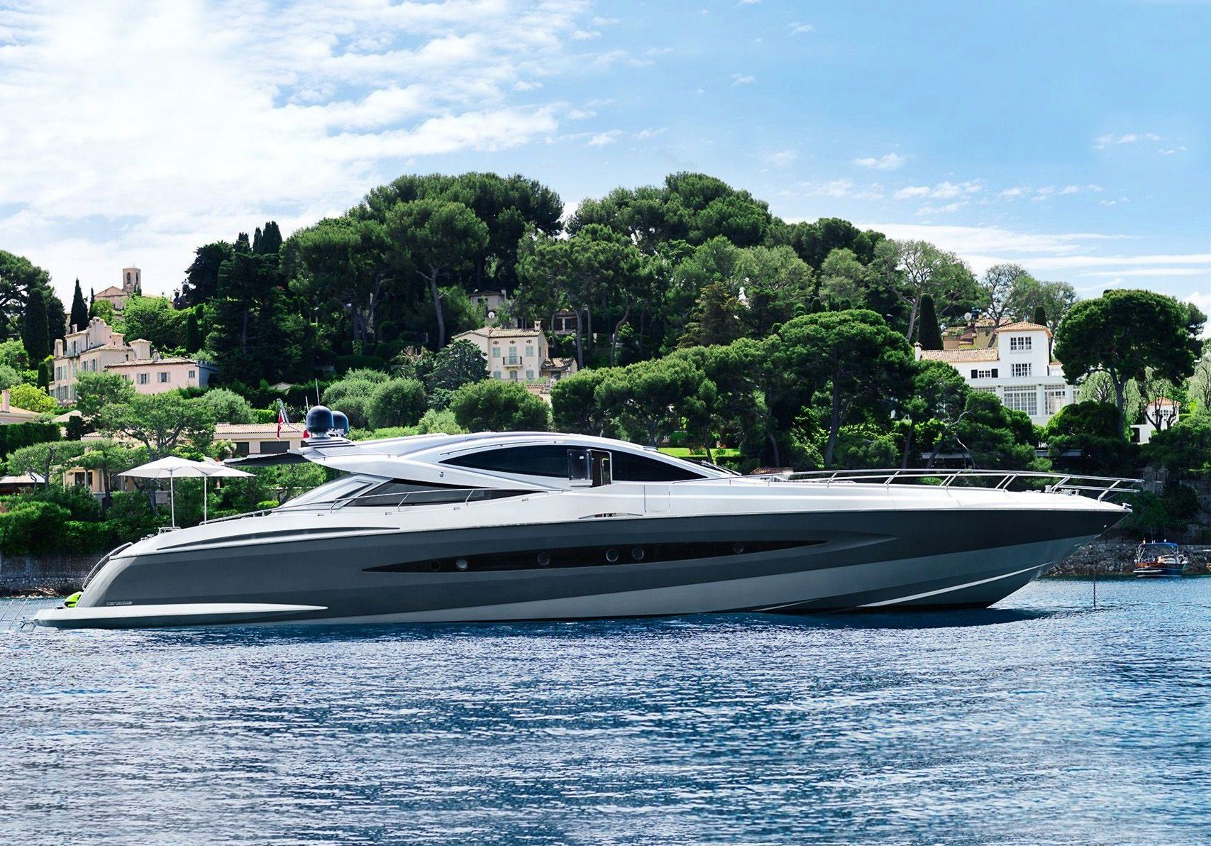
DESCRIPTION
Builder: | Canados
Built/Reﬁt: | 2008/ | Best Canados 90 Open on the Market - VAT Paid - Berth at Cap D Ail available.
Length: (m/ft) | 27.51 / 90'03"
Cabins: | 4
Guest: | 9
Crew: | 3 | Sales Price:
Cruising Speed: | 38 knots / 46 Max | €2,375,000
Location: | Cap d'Ail, France
All yachts offered are subject to still being available. Yacht particulars are believed to be correct but their contents are not guaranteed, neither may they be used for any contractual purposes. Specification provided for information only. Subject to prior sale, price change or withdrawal from market without notice.

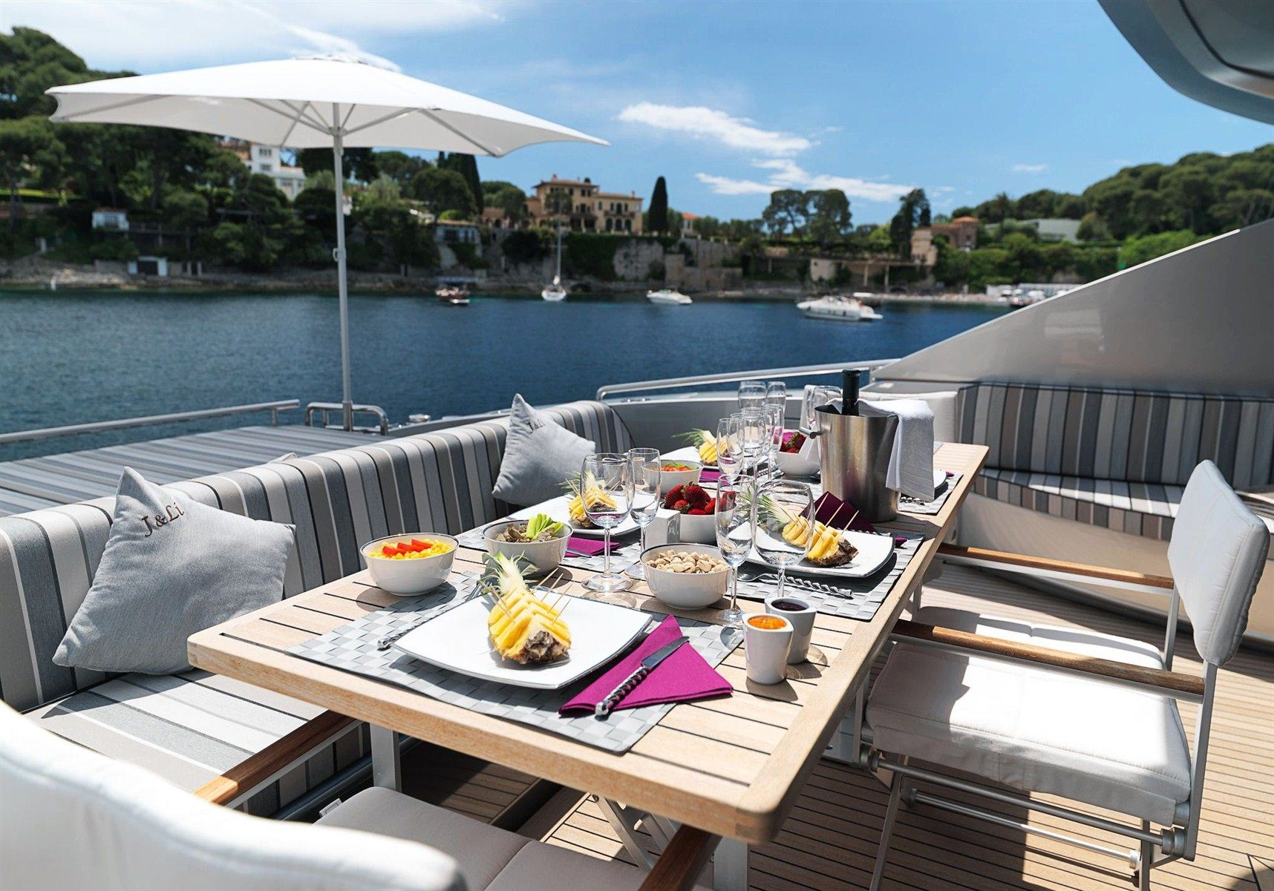
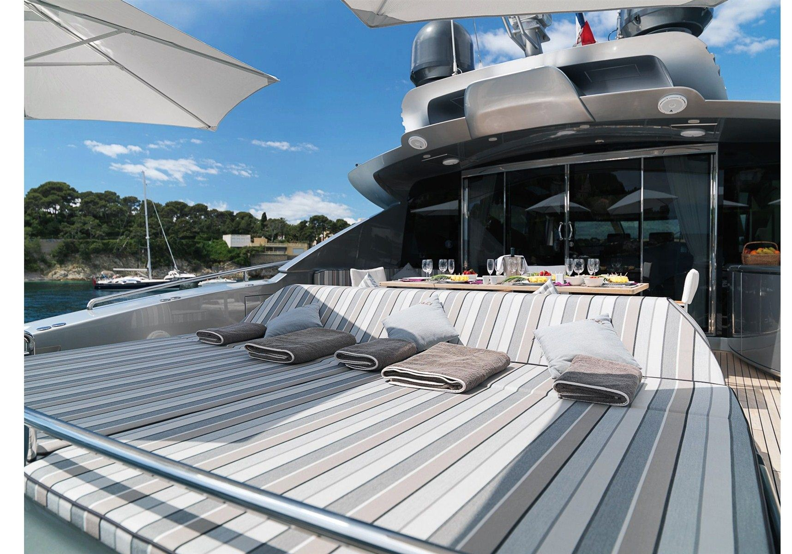 | 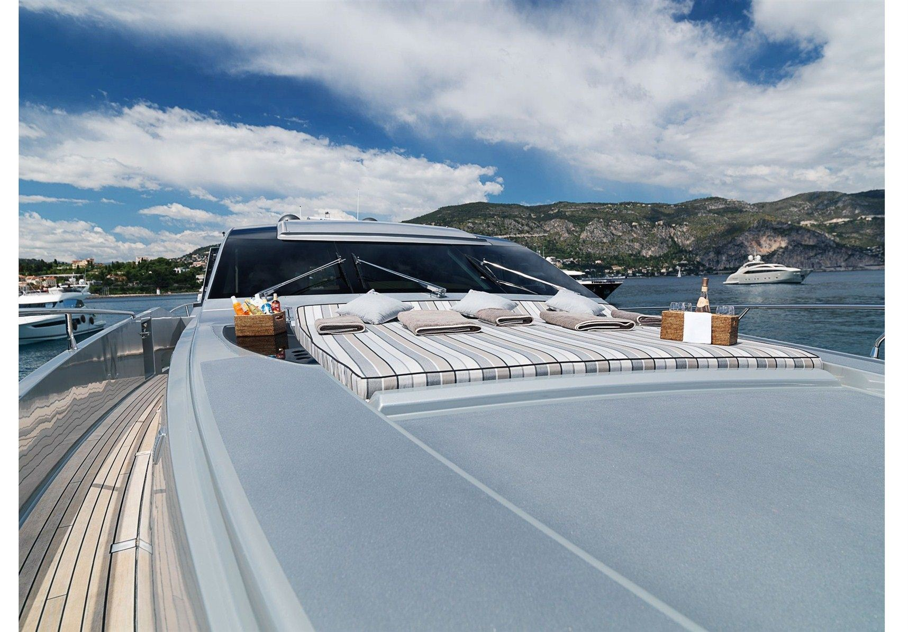

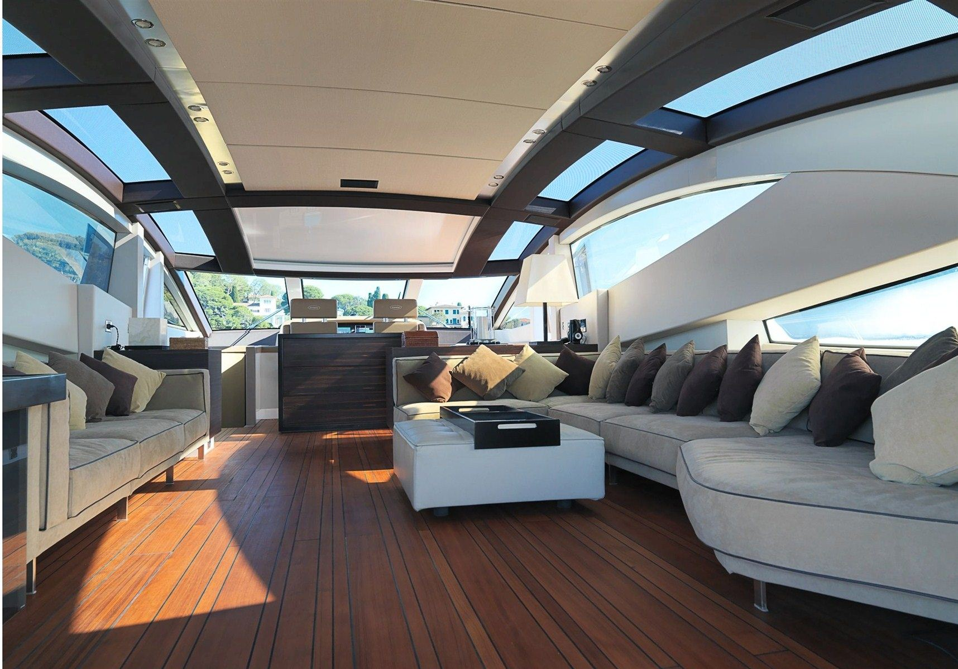
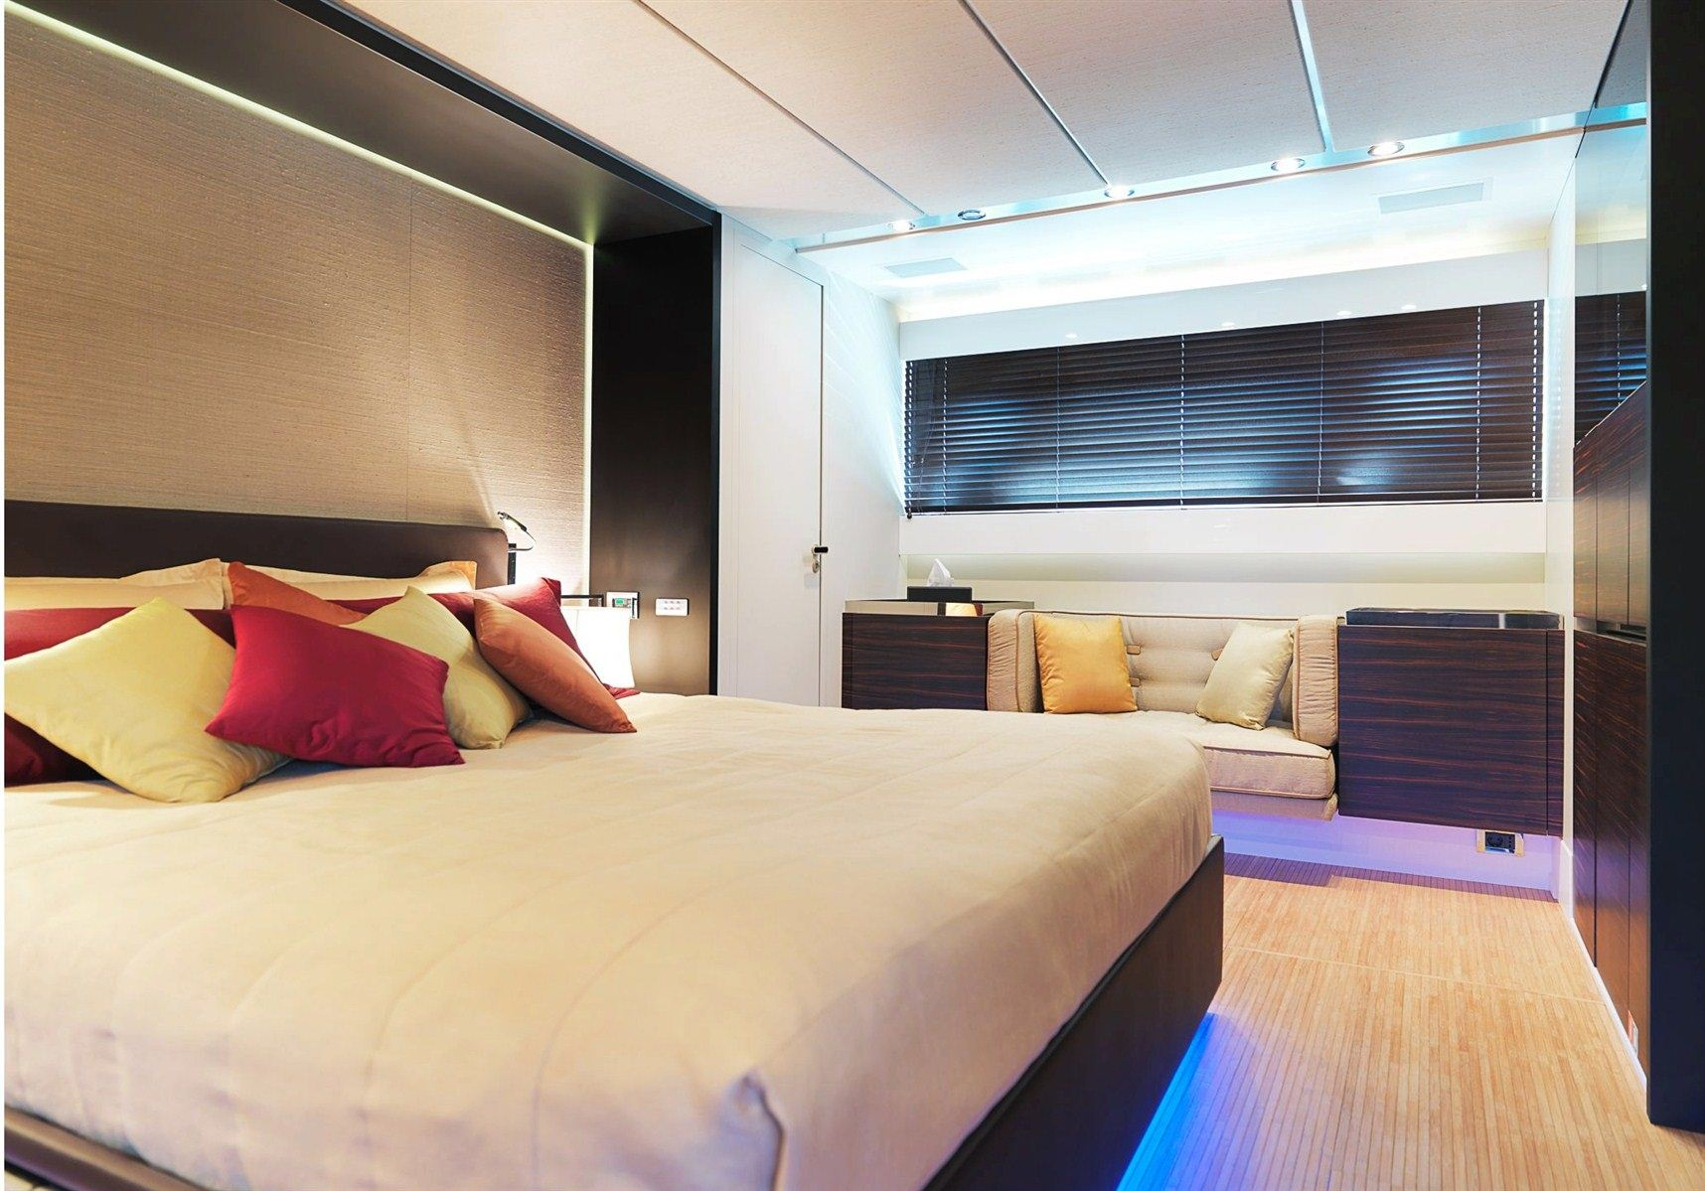 | 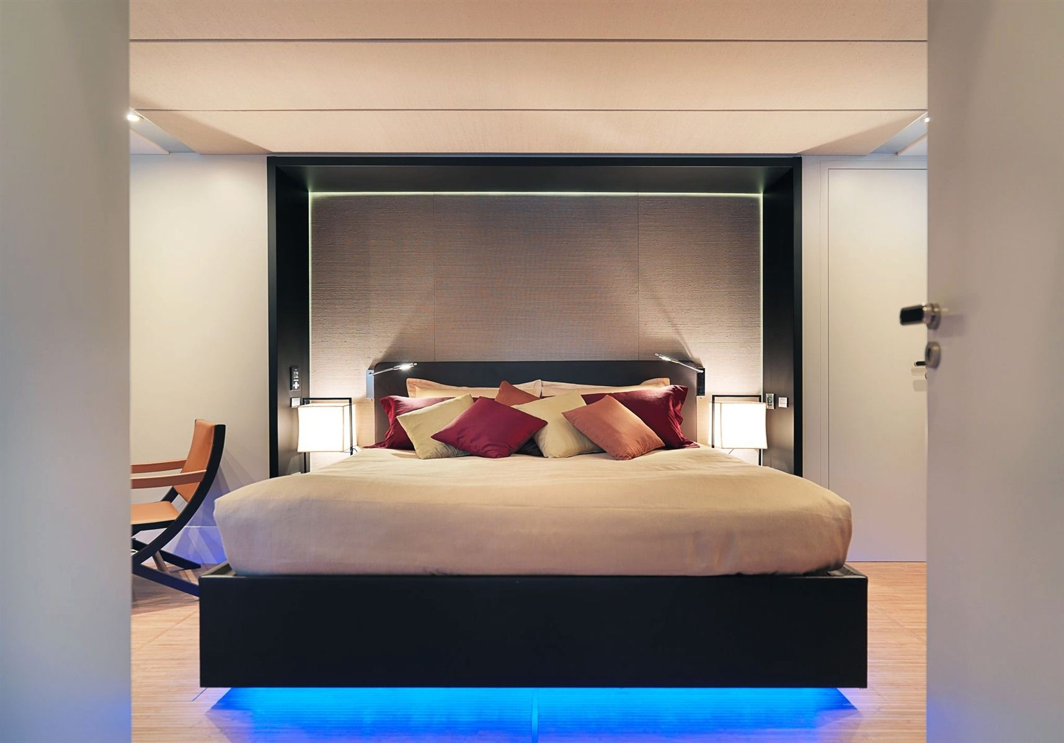

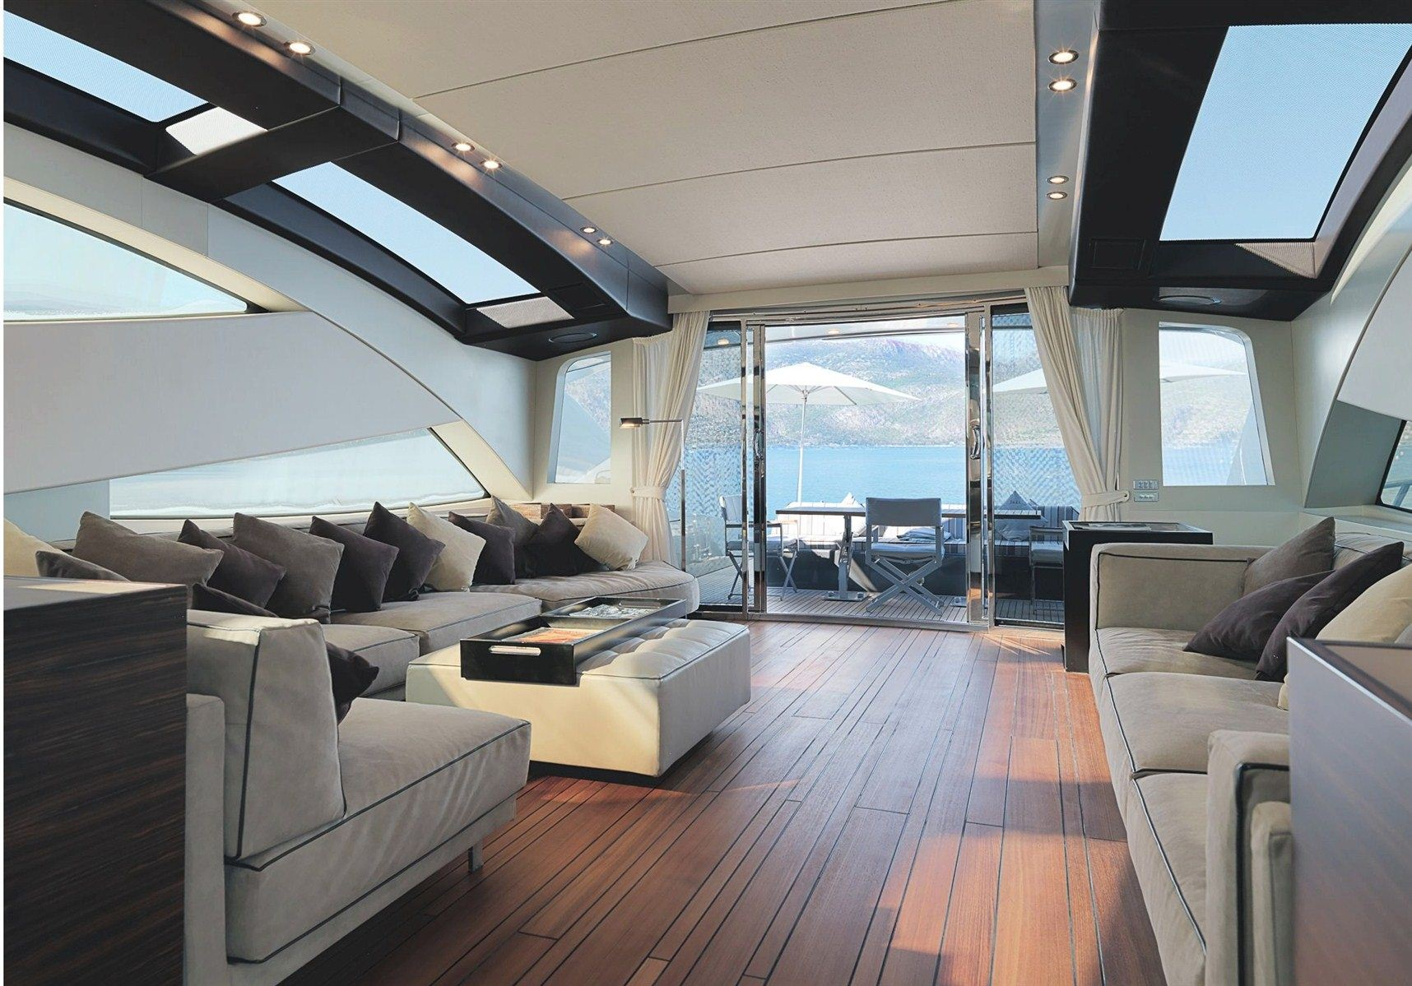
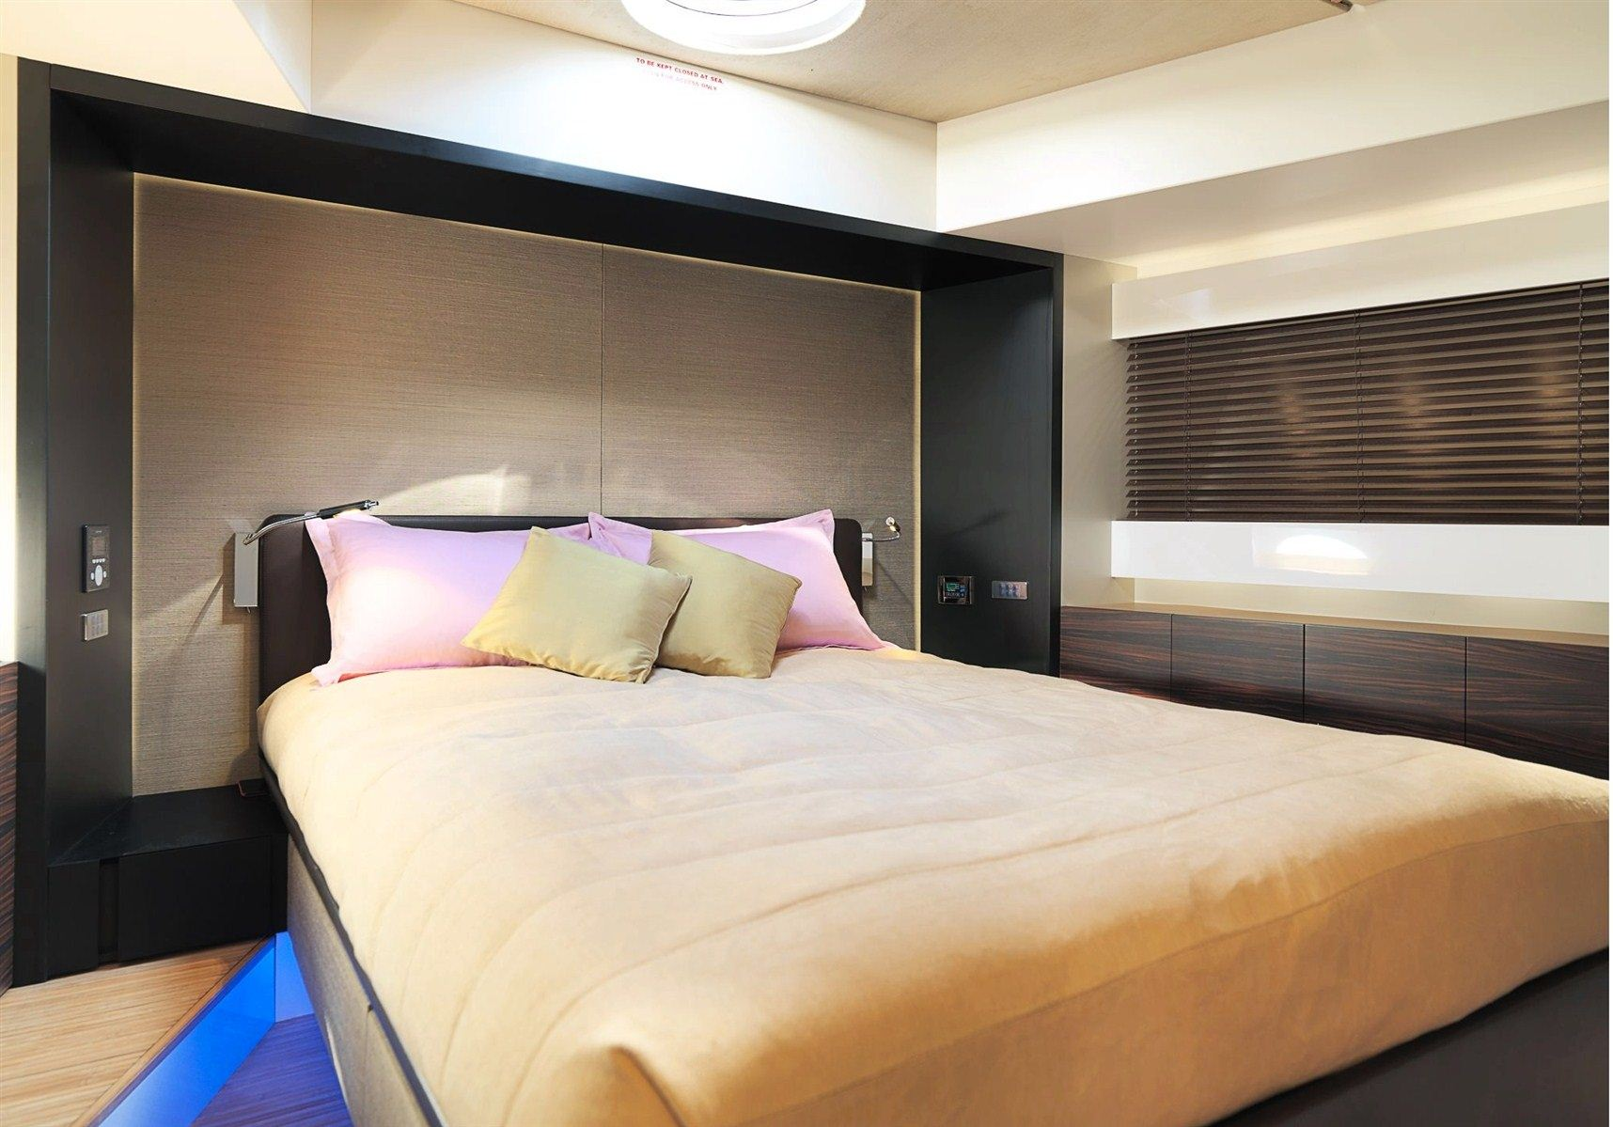 | 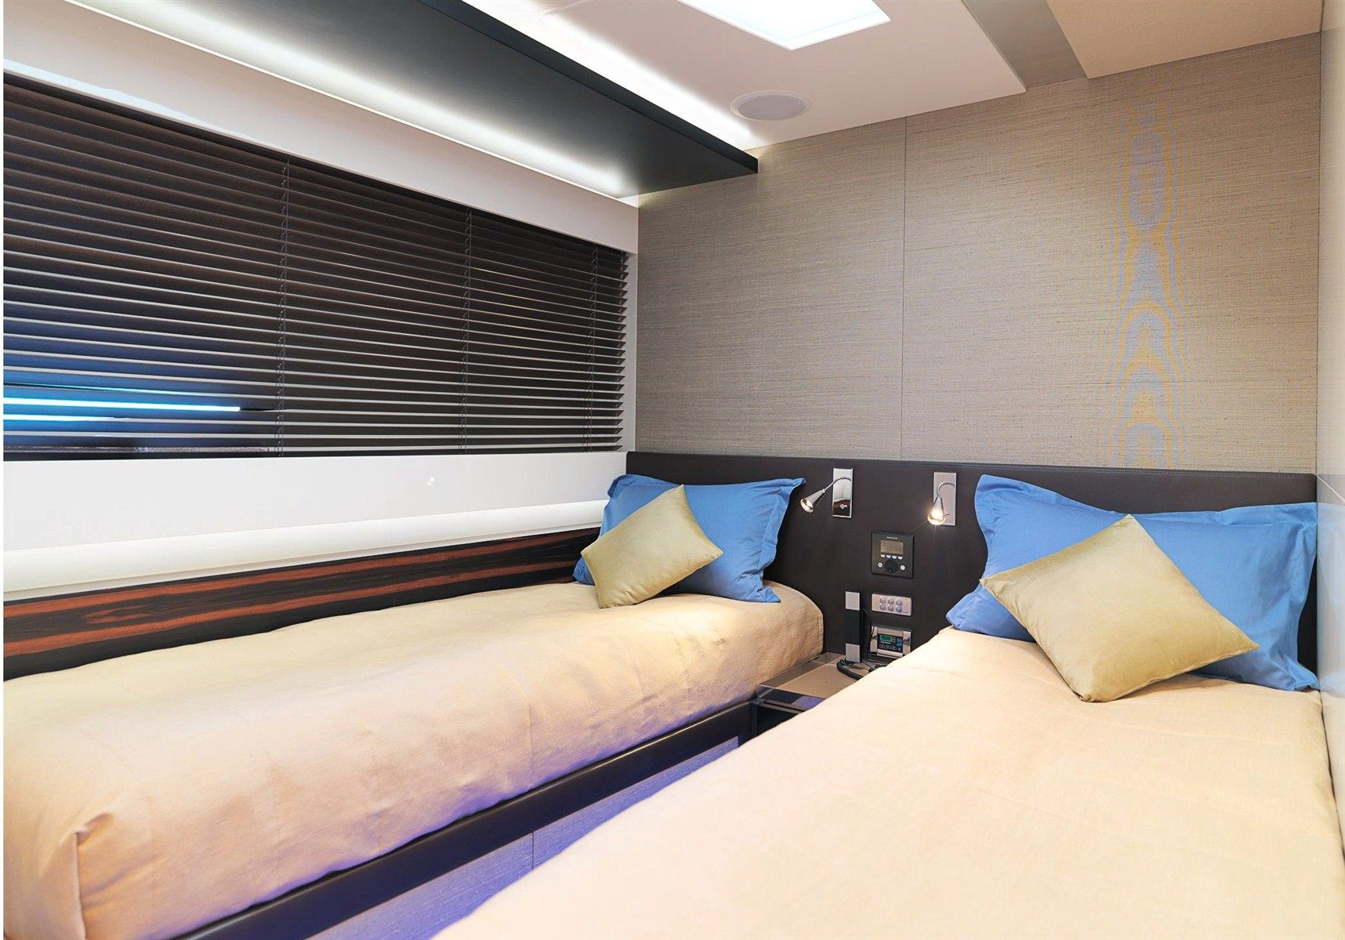

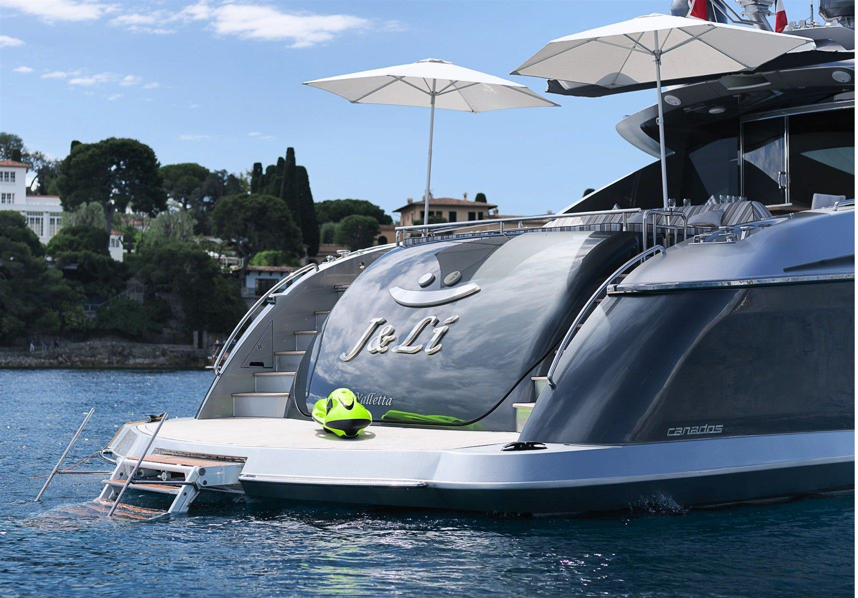
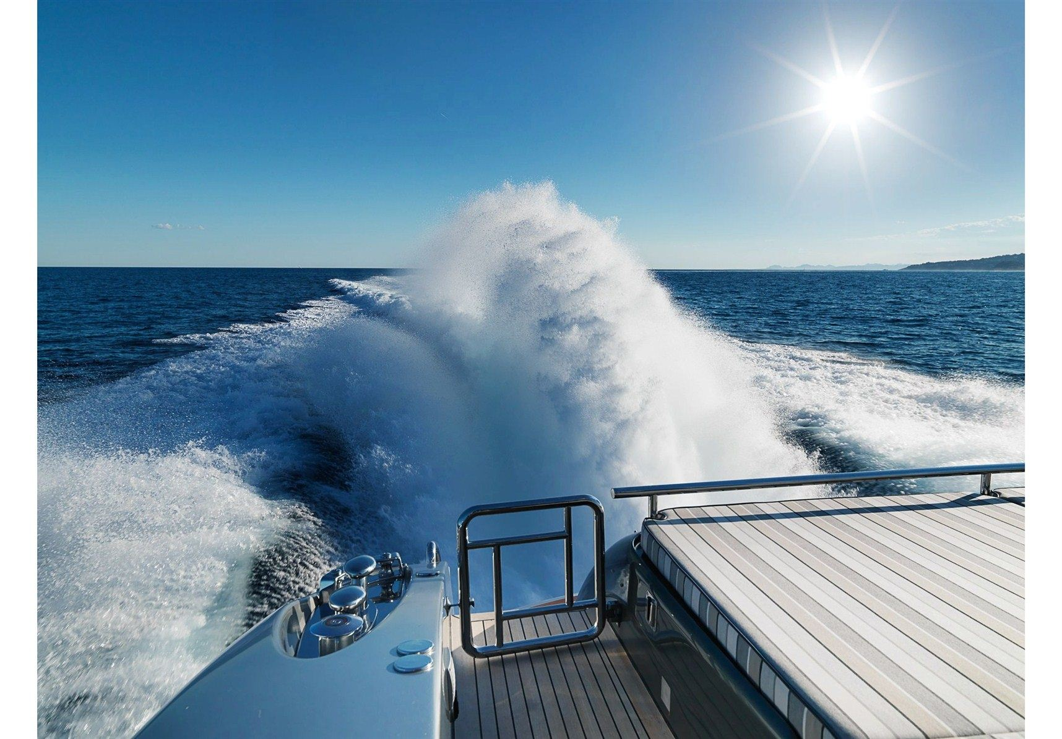 | 

